Mini Project -2

**Extracting and Interpreting the regular season Statistics of basketball**

**players.**

**OVERVIEW**

A project that gives you a better understanding of scraping data from websites and how to analyse them. Usage of various libraries as NumPy, Mat Plot, Pandas.

In the course of completing the project, you use the web scraping function, converting the extracted data into a pandas data Frame, and Storing the analysed data.

**Problem Statement**

Web scrape basketball statistics from Wikipedia of some of the greatest basketball players and export it as a CSV file format.

**Software Requirements**

1. Programming Language : Python

2. Environemnt: Jupyter Notebooks / Google Collab

3. Database: CSV(export type)

4. Operation System: Windows XP or above

5. Librarires Used: Beautiful Soup, requests, Pandas, NumPy, boto3 ,Matplotlib, display

1. **Open a New Notebook and import the required libraires**

|  |  |
| --- | --- |
|  | import bs4  import requests  import pandas as pd  import numpy as np  !pip install boto3  import boto3  import matplotlib.pyplot as plt  from IPython.display import display |

1. **Reading the webpage**

def get_basketball_stats(link='https://en.wikipedia.org/wiki/Michael_Jordan'):

response = requests.get(link)

soup = bs4.BeautifulSoup(response.text, 'html.parser')

1. **Main Function Process**

|  |  |
| --- | --- |
| table = soup.find(class_='wikitable sortable')  headers = table.tr  titles = headers.find_all('abbr')  data = {title['title']: [] for title in titles}  for row in table.find_all('tr')[1:]:  for key, a in zip(data.keys(),row.find_all('td')[2:]):  data[key].append(''.join(c for c in a.text if (c.isdigit() or c == '.')))  Min = min([len(x) for x in data.values()])  for key in data.keys():  data[key] = list(map(lambda x: float(x), data[key][:Min]))  return data  **5.Declaring links and names of the personals to scrap the data** |  |
| links=['https://en.wikipedia.org/wiki/Michael_Jordan'\  ,'https://en.wikipedia.org/wiki/Kobe_Bryant'\  ,'https://en.wikipedia.org/wiki/LeBron_James'\  ,'https://en.wikipedia.org/wiki/Stephen_Curry']  names=['Michael Jordan','Kobe Bryant','Lebron James','Stephen Curry'] |  |

michael_jordan_dict = get_basketball_stats(links[0])

kobe_bryant_dict = get_basketball_stats(links[1])

lebron_james_dict = get_basketball_stats(links[2])

stephen_curry_dict = get_basketball_stats(links[3])

mj_table = pd.DataFrame(michael_jordan_dict)

kb_table = pd.DataFrame(kobe_bryant_dict)

lj_table = pd.DataFrame(lebron_james_dict)

sc_table = pd.DataFrame(stephen_curry_dict)

list_table =[mj_table, kb_table, lj_table, sc_table]

i = 0

for name in names:

    print(name)

    display(list_table[i])

    i += 1

**Output:**

|  |  |
| --- | --- |
|  |  |

1. **Combining various variables into a single dictionary & data framing the Dictionary using Pandas**

|  |  |
| --- | --- |
|  | dictionary = {'BusinessNames': BusinessNames, 'Address': Address, 'State': state_name, 'Phone': Phone,  'Urls': Urls}  df=pd.DataFrame(dict([(k,pd.Series(v)) for k,v in dictionary.items()])) |

1. **Converting the Data frames into CSV File**

|  |  |
| --- | --- |
|  | df.to_csv(''+state_name+'.csv',encoding='utf-8-sig')  print('saved as a file') |

1. **Downloading The CSV file from Google Collab**

|  |  |
| --- | --- |
|  | from google.colab import files  files.download(''+state_name+'.csv') |

**A Glimpse of the CSV File**

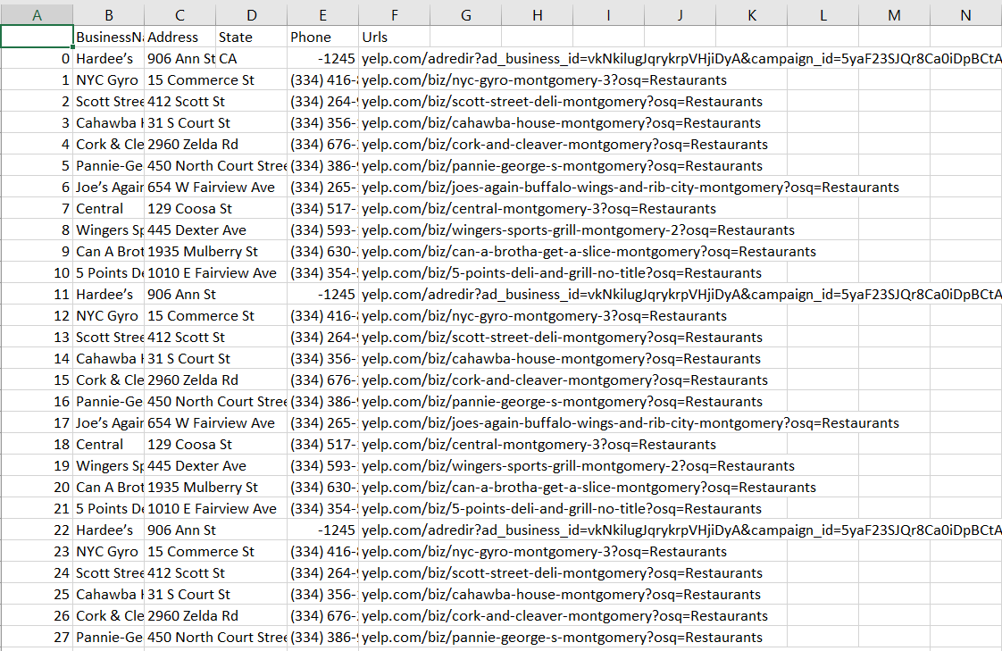

**Conclusion**

Therefore we have successfully scraped the Data of 100+ restaurants along with their mobile numbers, addresses & URLs using Python